# **Scalable Web Application Deployment on AWS**

## **Project Objective**

**Objective:**

The primary objective of this project is to develop a scalable web application using AWS services. The application will involve setting up an auto-scaling environment integrated with a load balancer and leveraging Amazon S3 for efficient image storage. This setup aims to ensure high availability, fault tolerance, and optimal performance under varying loads, providing a seamless user experience.

## **Use Case**

**Use Case Description:**

In this project, we aim to build a web application for a hypothetical e-commerce platform that displays product pages. The application needs to handle varying traffic loads efficiently, provide fast image delivery, and maintain high availability. The architecture will be built using AWS services to ensure scalability, reliability, and cost-effectiveness.

### **Use Case Scenarios:**

1. **High Traffic Management:**
   * During promotional events or sales, the application may experience spikes in traffic. The auto-scaling feature will dynamically adjust the number of running instances to handle the increased load without performance degradation.
2. **Image Hosting and Delivery:**
   * Product images need to be stored centrally and served quickly to users. Amazon S3 will be used to store these images, providing reliable and fast access through the web server.
3. **Infrastructure Monitoring and Alerts:**
   * To maintain service health and performance, infrastructure changes like instance launches or terminations need to be monitored. Amazon SNS will send notifications to the team for immediate awareness and action.

## **Key Features**

**1. Auto-Scaling:**

* **Dynamic Scaling:** Automatically adjusts the number of EC2 instances based on traffic load to maintain optimal performance.
* **Cost Efficiency:** Reduces costs by running only the necessary number of instances at any given time.

**2. Load Balancing:**

* **Traffic Distribution:** The Application Load Balancer evenly distributes incoming traffic across multiple instances to ensure no single instance is overwhelmed.
* **High Availability:** By distributing traffic across instances in multiple availability zones, the system remains operational even if some instances fail.

**3. S3 Image Storage:**

* **Centralized Storage:** Amazon S3 provides a centralized location for storing images, ensuring high availability and durability.
* **Efficient Access:** Images are accessed directly from S3, reducing the load on web servers and improving page load times.

**4. Infrastructure Monitoring and Notifications:**

* **Real-time Alerts:** Amazon SNS sends real-time notifications about infrastructure events, enabling quick responses to changes.
* **System Health Visibility:** Continuous monitoring of instance status and performance ensures system reliability and user satisfaction.

**5. Easy Deployment and Management:**

* **AMI and Launch Templates:** Simplify instance configuration and deployment, ensuring consistency across instances.
* **Scalability:** The architecture can easily be expanded to accommodate additional resources or features as needed.

**Architecture**

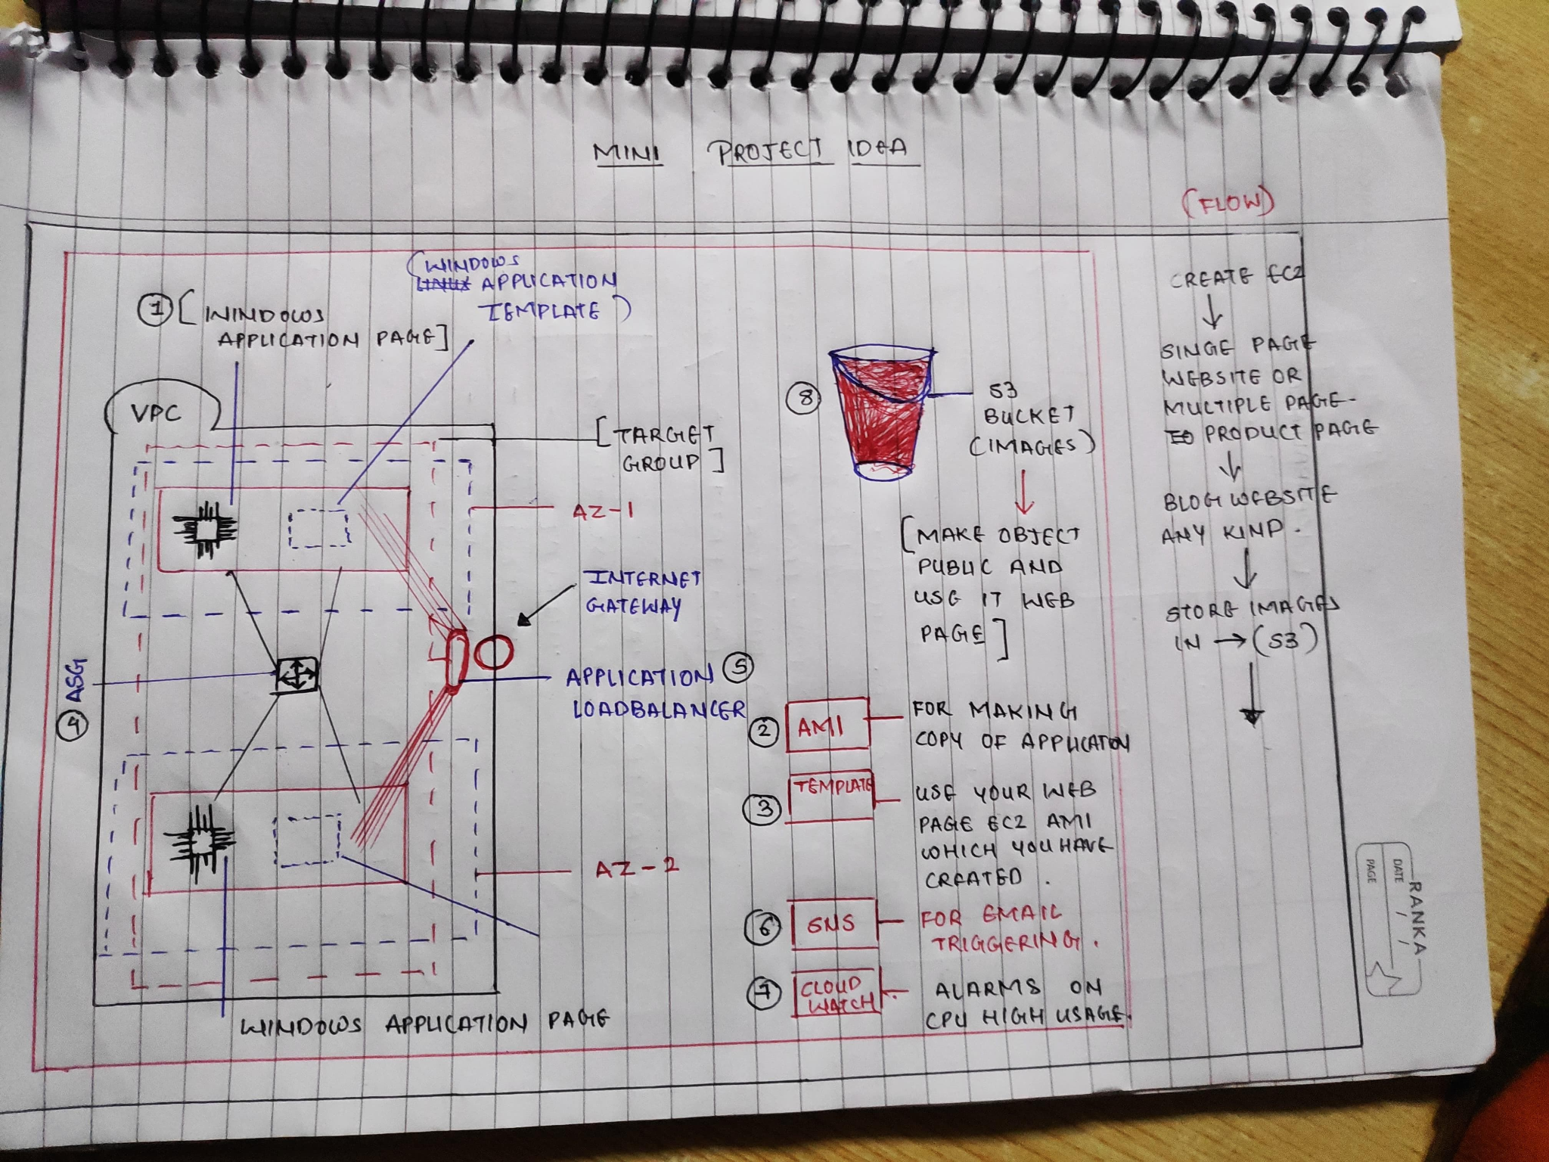

## **Service Descriptions**

### **Amazon EC2 (Elastic Compute Cloud)**

Amazon EC2 provides resizable compute capacity in the cloud, allowing you to run virtual servers, known as instances, on demand. EC2 enables you to launch, manage, and scale applications efficiently with various instance types tailored to your workload.

### **Amazon S3 (Simple Storage Service)**

Amazon S3 is an object storage service that offers industry-leading scalability, data availability, security, and performance. It is designed to store and retrieve any amount of data from anywhere on the web, making it ideal for hosting static content such as images.

### **Amazon Auto Scaling**

Amazon Auto Scaling helps maintain application availability by automatically adjusting the number of EC2 instances based on demand. It enables scaling policies to ensure that the number of instances increases or decreases according to traffic.

### **Amazon Load Balancer (Application Load Balancer)**

The Application Load Balancer distributes incoming application traffic across multiple targets, such as EC2 instances, in different Availability Zones. It enhances the fault tolerance of applications and ensures that requests are distributed efficiently.

### **Amazon SNS (Simple Notification Service)**

Amazon SNS is a fully managed messaging service for sending notifications from the cloud. It supports various communication protocols, including email, SMS, and HTTP/S endpoints, enabling you to receive notifications about changes or events in your infrastructure.

**MY-WEBSITE**

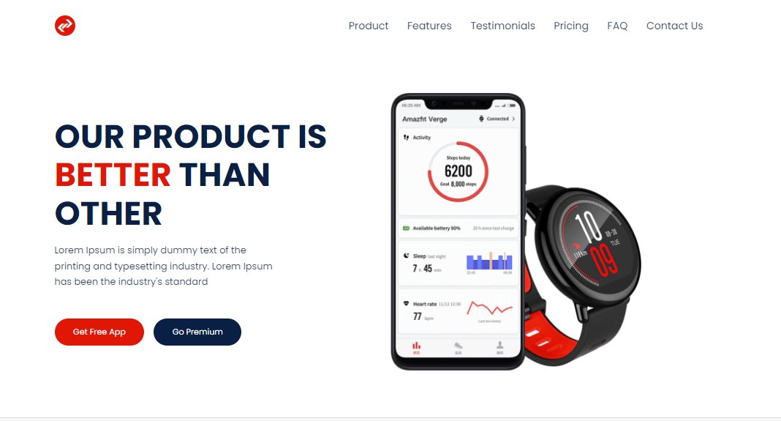

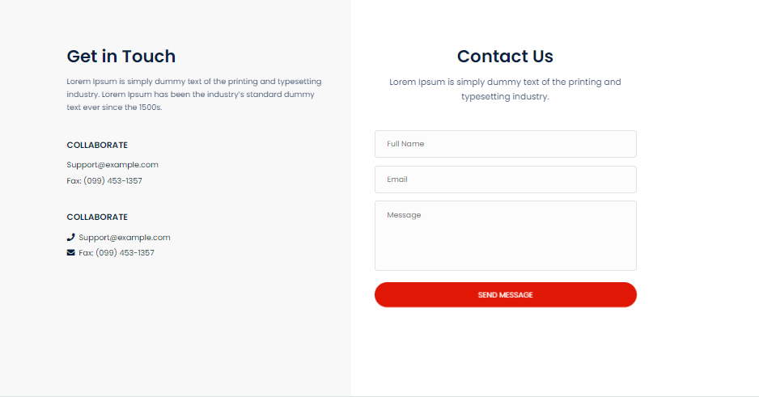

### **Step 1: Use S3 for Image Storage**

**Objective:** Store images in Amazon S3 and link them in the HTML page.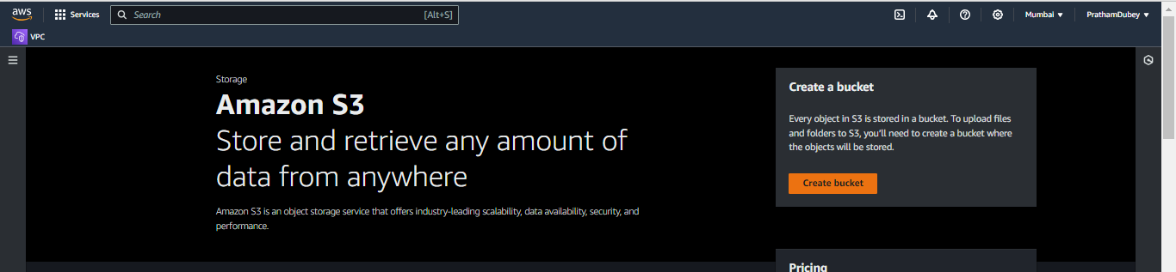

1. **Create S3 Bucket:**
   * Navigate to the S3 dashboard.
   * Click on "Create Bucket."
   * Enter a unique bucket name and configure settings (leave default for this project).

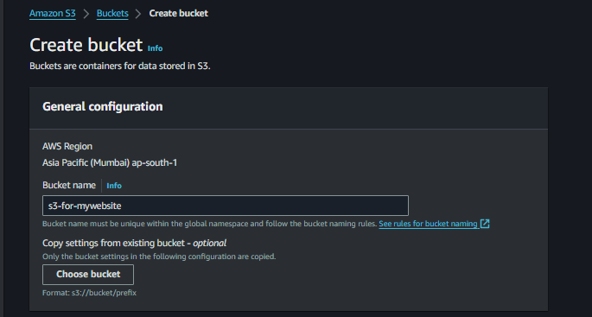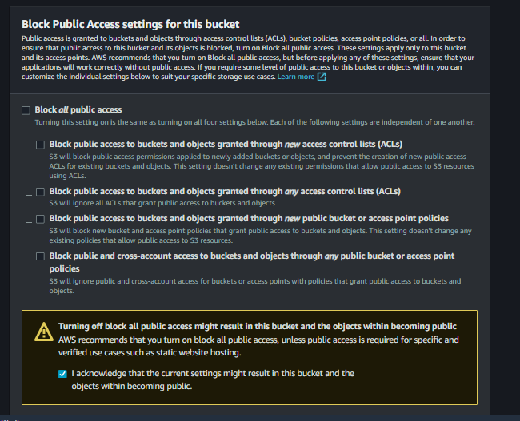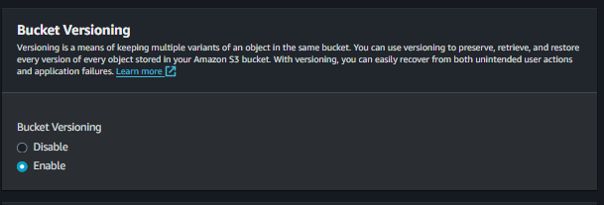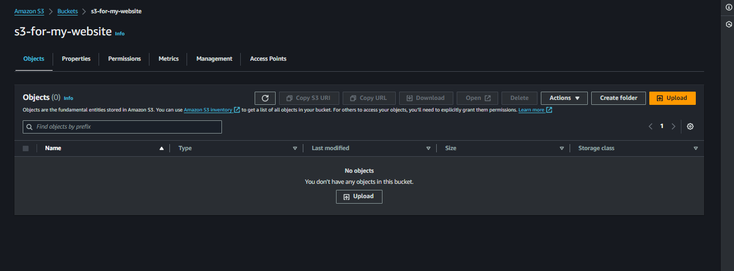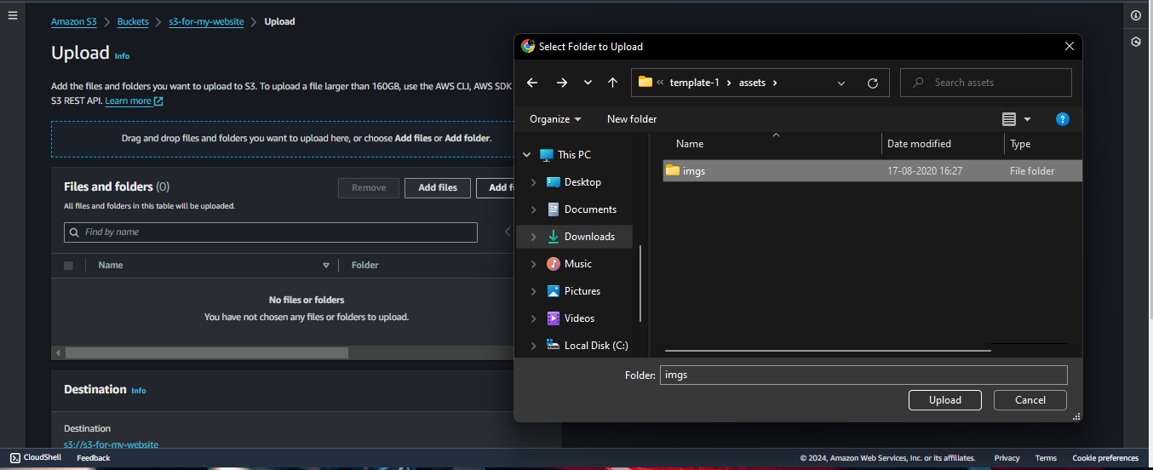

1. **Upload Images:**
   * Click on your bucket name.
   * Upload images that you want to display on your HTML page

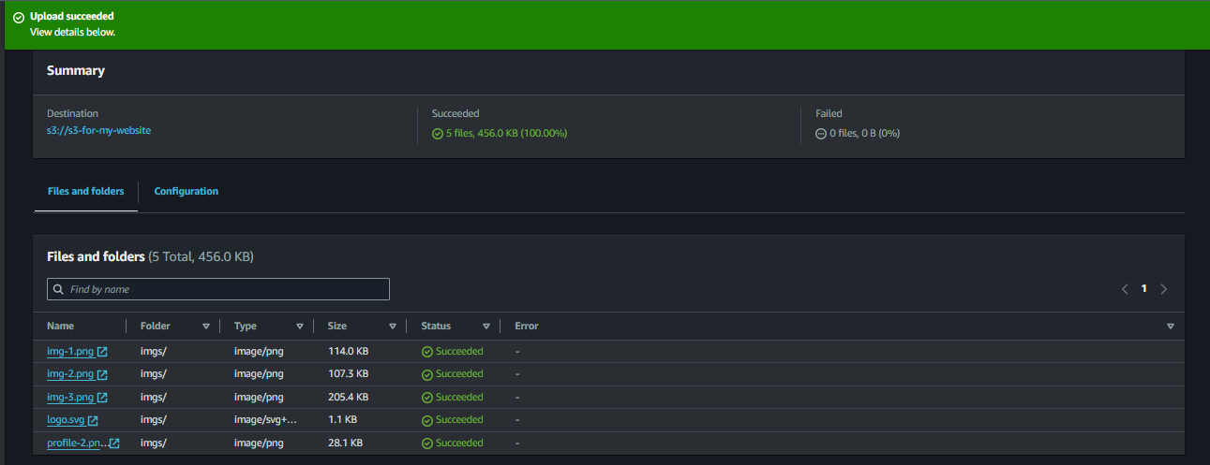

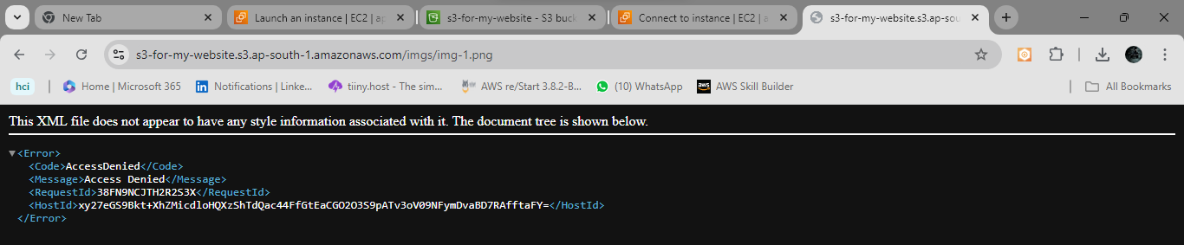

1. **Make Images Public:**
   * Click on each image.
   * Navigate to the "Permissions" tab and enable "Public access" or use a bucket policy to make all images public.

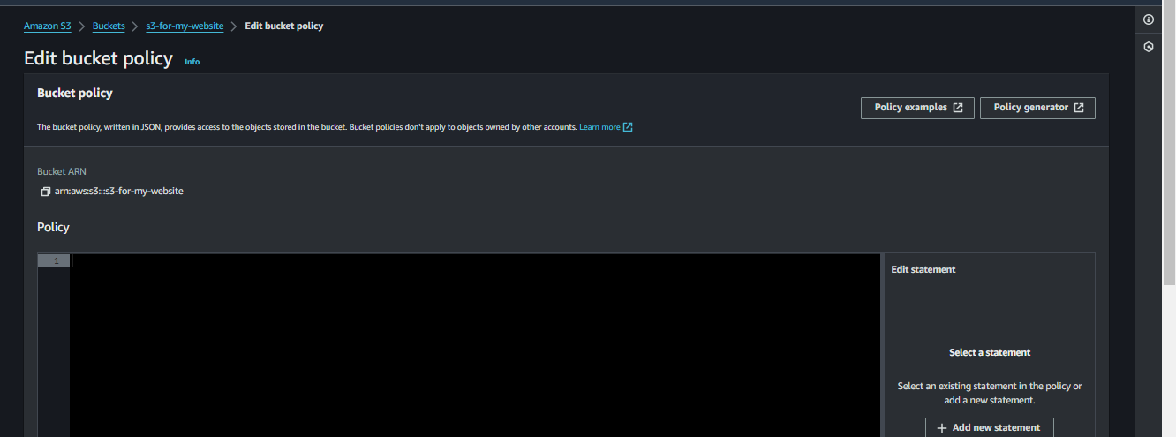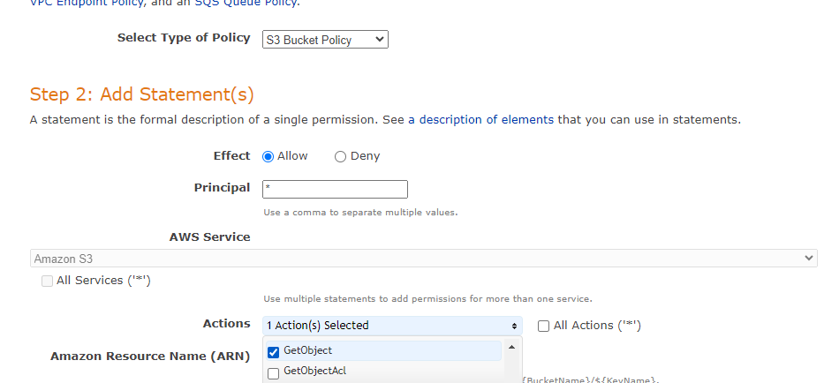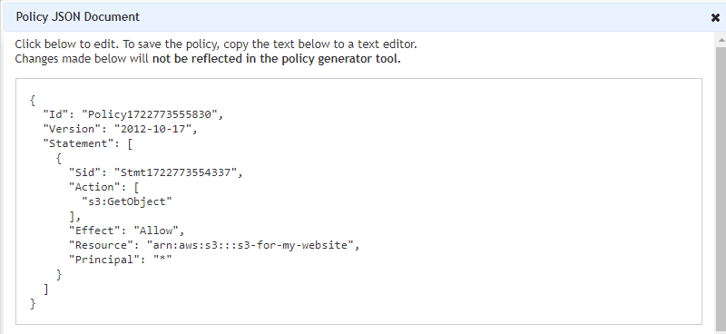

"Effect": "Allow",

Must give( "Resource": "arn:aws:s3:::s3-for-my-website/*",)

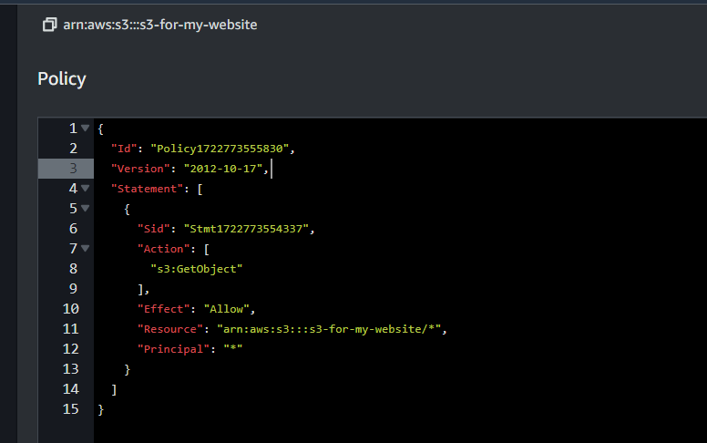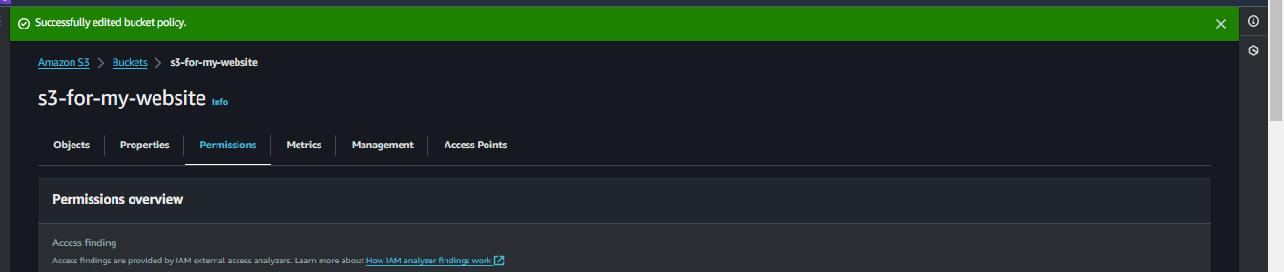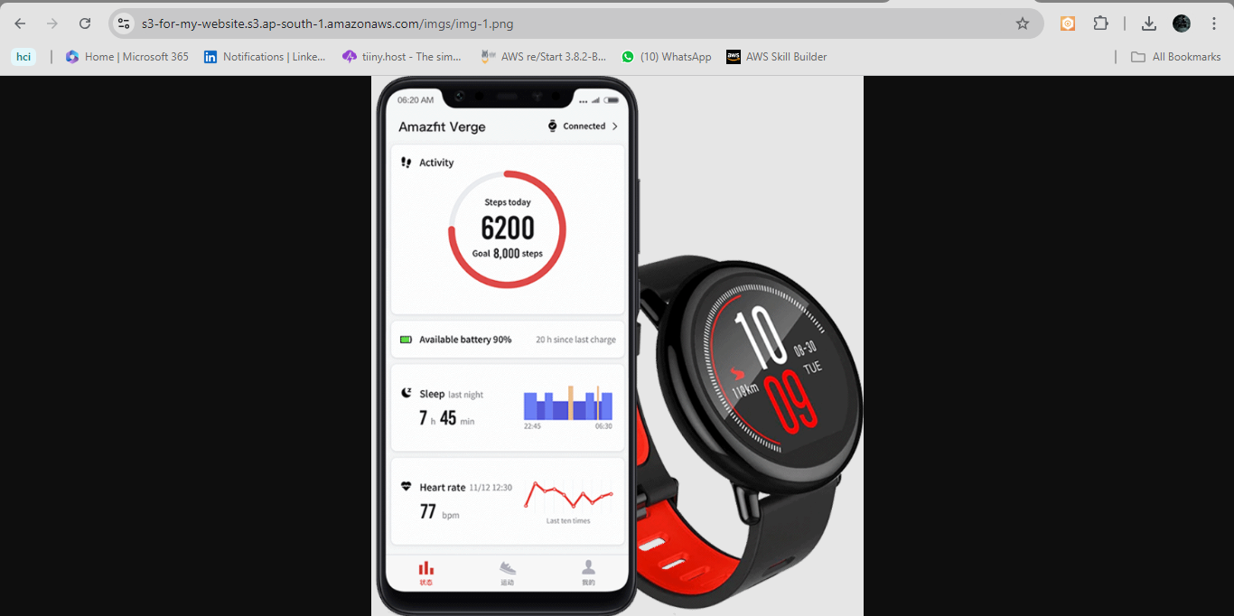

1. **Update HTML Links:**
   * Copy the S3 object URLs of your images.
   * Update the HTML image tags with these URLs.

### **Step 2: Create a Windows EC2 Instance**

**Objective:** Launch a Windows instance that will serve as the web server.

1. **Navigate to EC2 Dashboard:**
   * Sign in to your AWS Management Console.
   * Navigate to the EC2 dashboard.

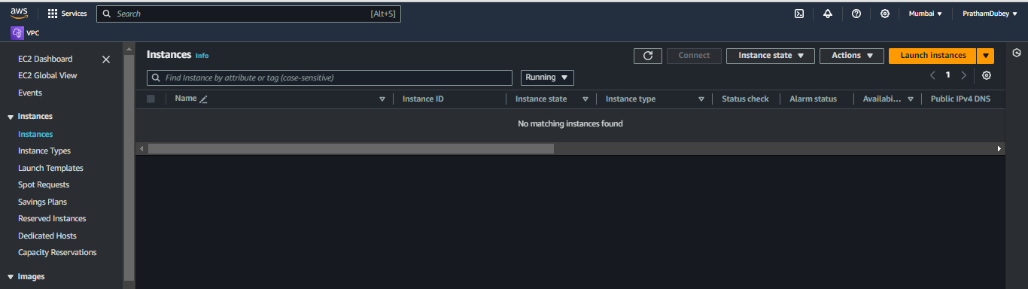

1. **Launch Instance:**
   * Click on "Launch Instance."
   * Choose the "Microsoft Windows Server" Amazon Machine Image (AMI).
   * Select an instance type (e.g., t2.micro for free tier).
   * Configure instance details such as the number of instances, VPC, subnet, and auto-assign public IP.

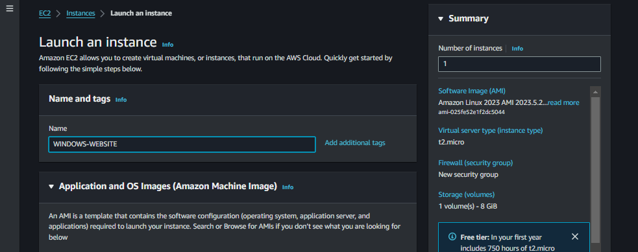Create a new security group.

* + Add a rule for RDP (Remote Desktop Protocol) on port 3389.
  + Add a rule for HTTP on port 80 to allow web traffic.

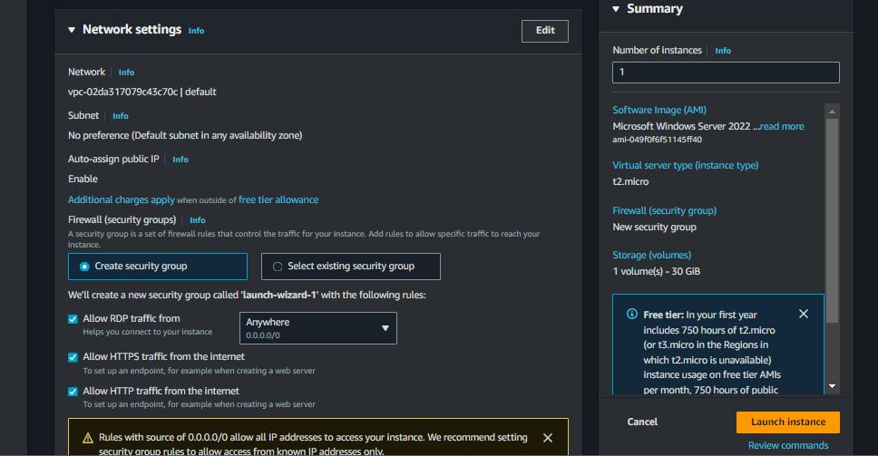

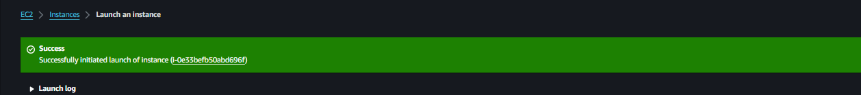**Launch and Connect:**

* + Review and launch the instance.
  + Connect to the instance using RDP to access the Windows environment.

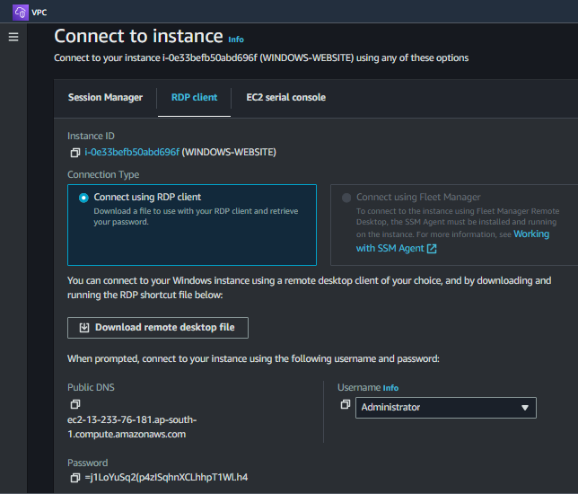

=j1LoYuSq2(p4zISqhnXCLhhpT1Wl.h4

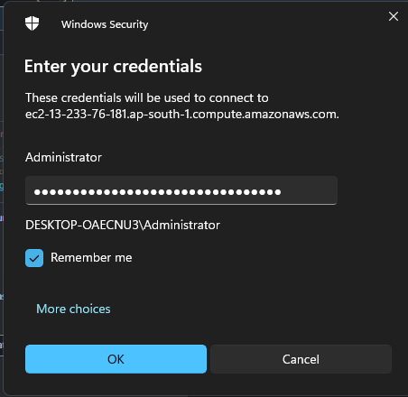

### **Step 3: Set Up a Web Server**

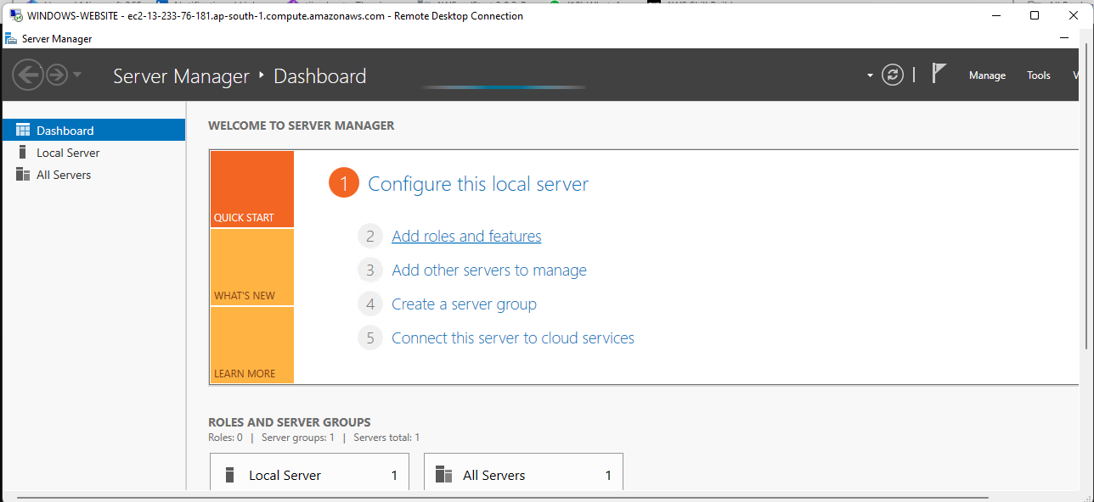

**Objective:** Deploy a web server to host an HTML page.

1. **Install Web Server:**
   * Connect to the Windows instance via RDP.
   * Install IIS (Internet Information Services) through the Server Manager.

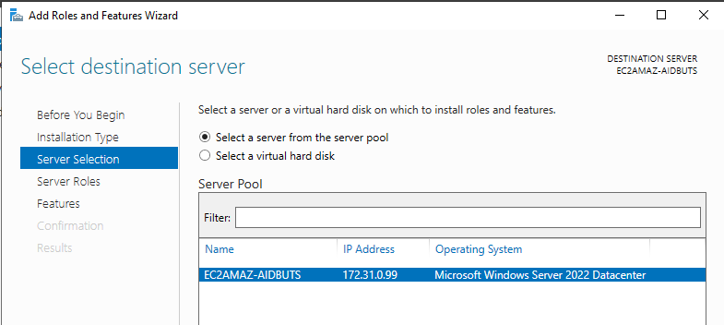

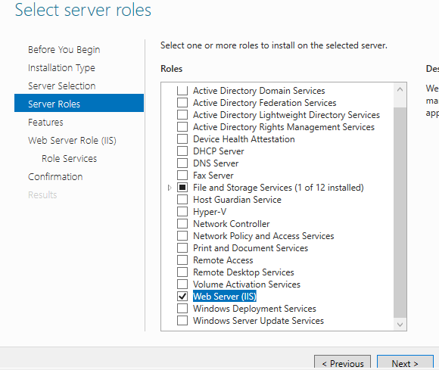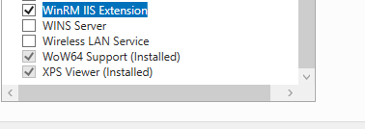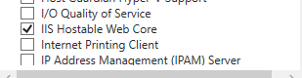

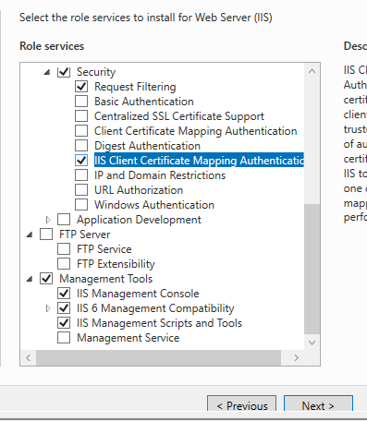

1. **Deploy HTML Page:**
   * Create a simple HTML file for your product page.
   * Include image tags linking to your S3 bucket images.
   * Save the HTML file in the IIS web root directory (e.g., C:\inetpub\wwwroot).



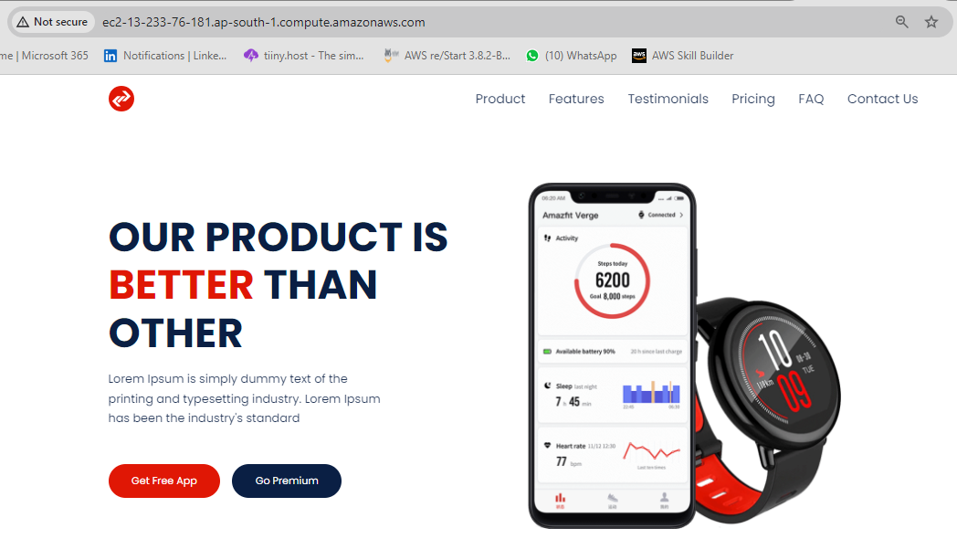

### **Step 4: Create an AMI and Launch Template**

**Objective:** Create an AMI of your configured instance and a launch template for auto-scaling.

1. **Create AMI:**
   * Go to the EC2 dashboard.
   * Select your instance.
   * Click on "Actions" > "Image" > "Create Image."

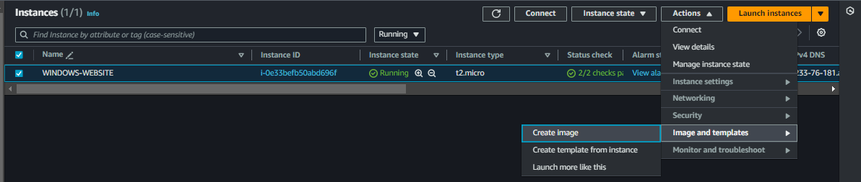

* + Enter image name and description, then create the AMI

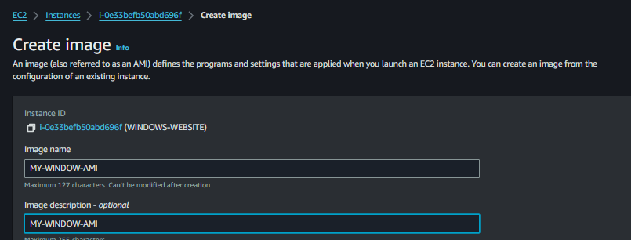

1. **Create Launch Template:**
   * Navigate to "Launch Templates" in the EC2 dashboard.

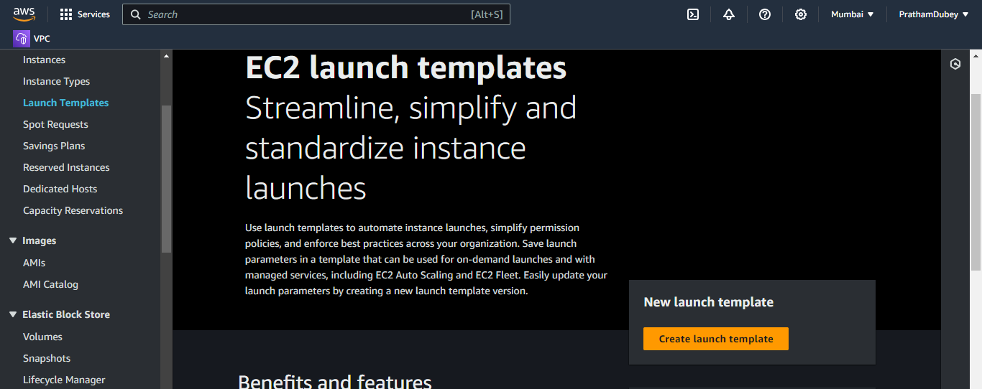

* + Click on "Create Launch Template."
  + Provide a name and select the AMI created earlier.
  + Configure instance type, network settings, and security groups.

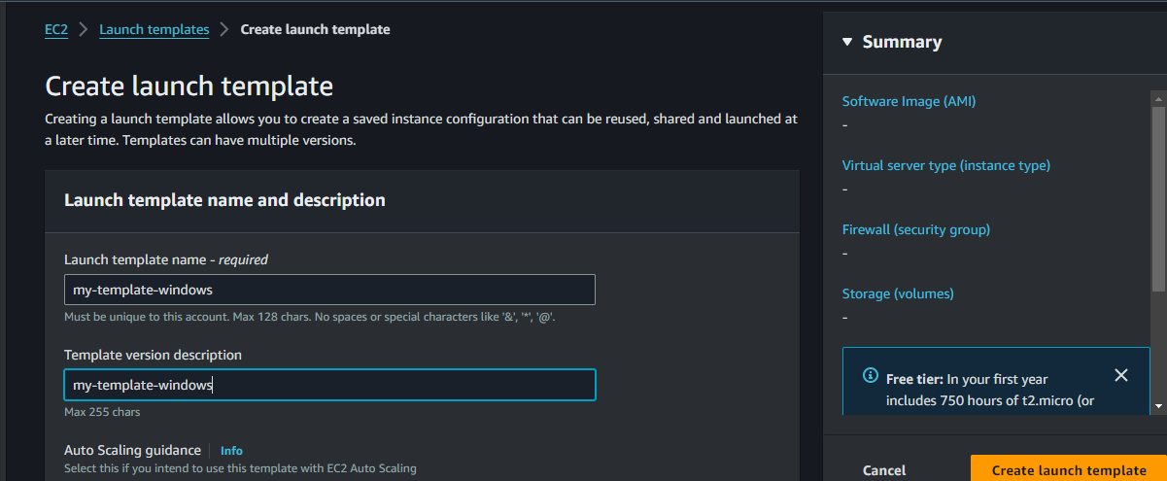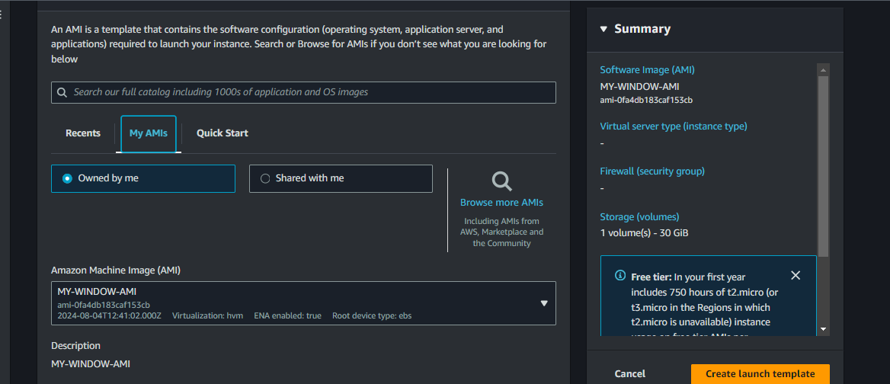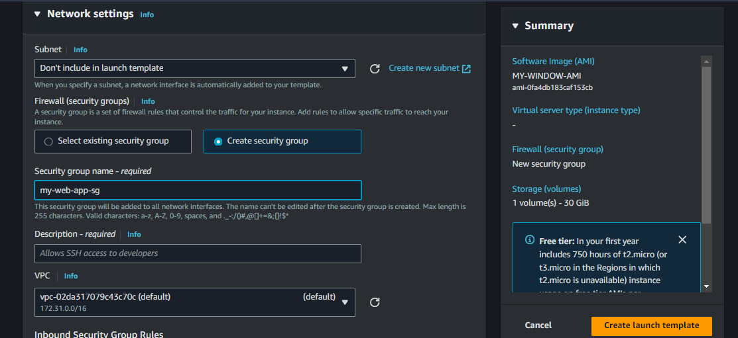

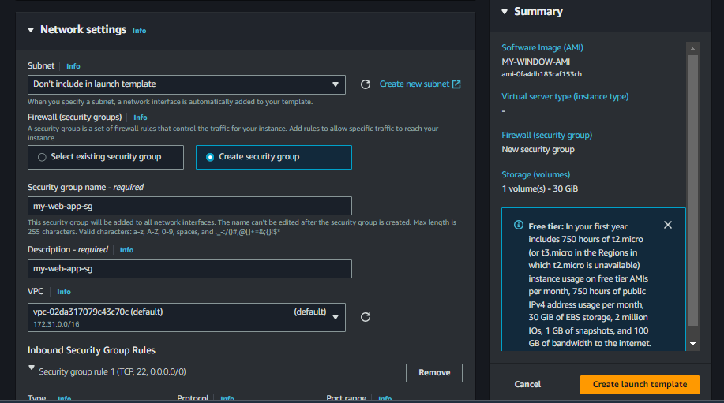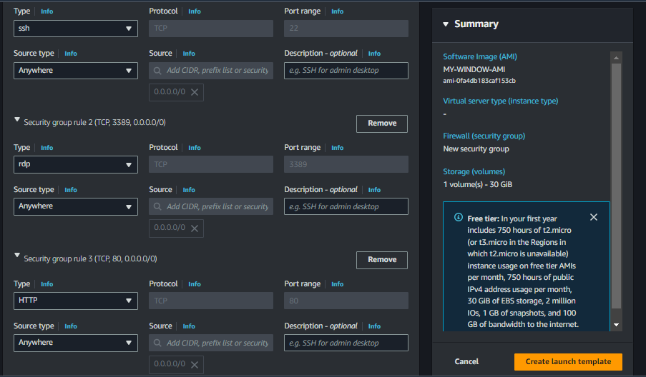

### 

### **Step 5: Set Up Auto Scaling**

**Objective:** Automatically adjust the number of instances based on load.

1. **Create Auto Scaling Group:**
   * Go to the "Auto Scaling Groups" section in the EC2 dashboard.
   * Click on "Create Auto Scaling group."
   * Choose your launch template.
   * Configure group size, VPC, and subnets.

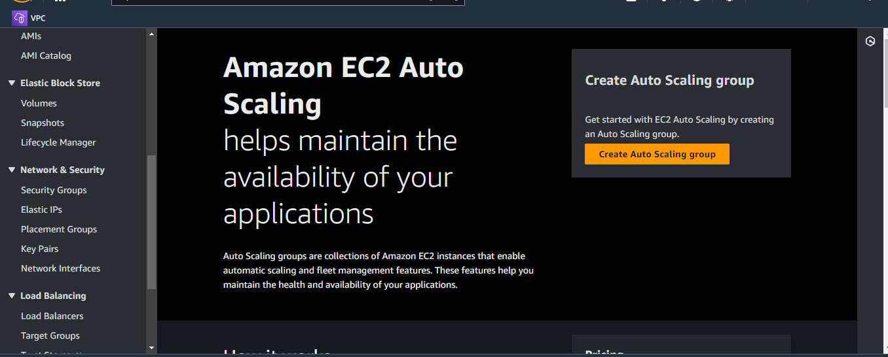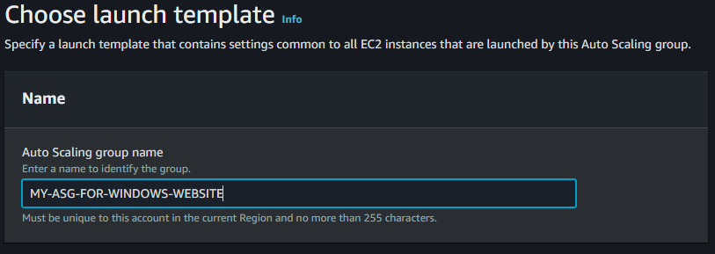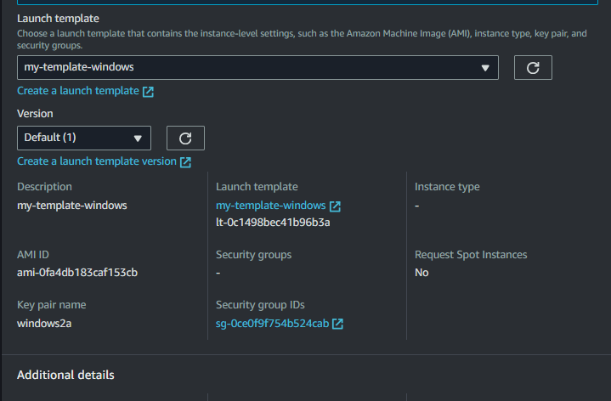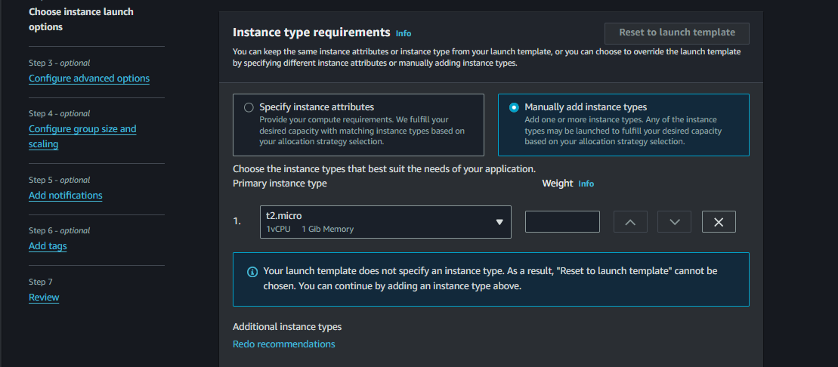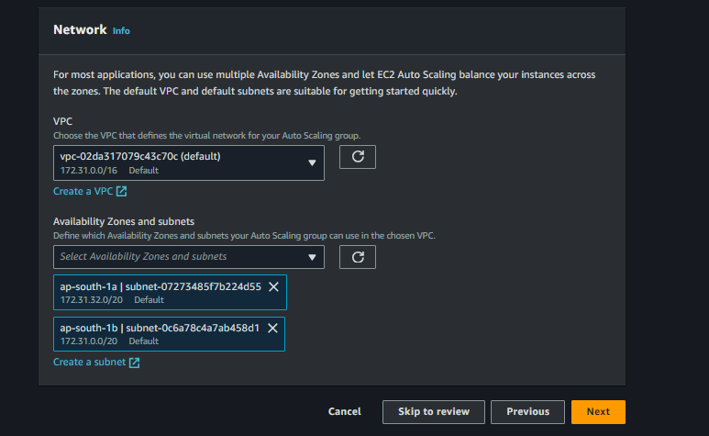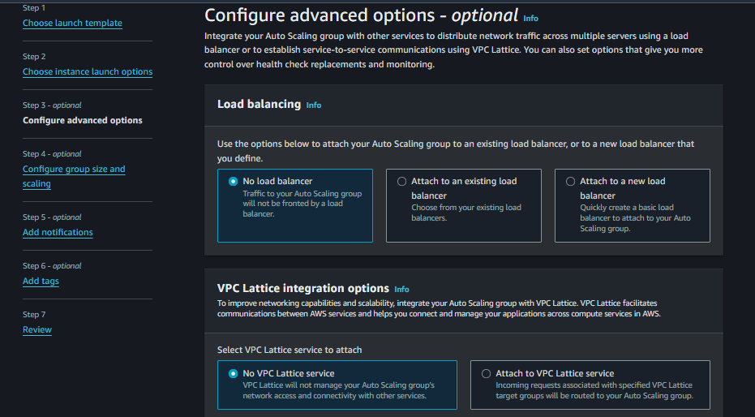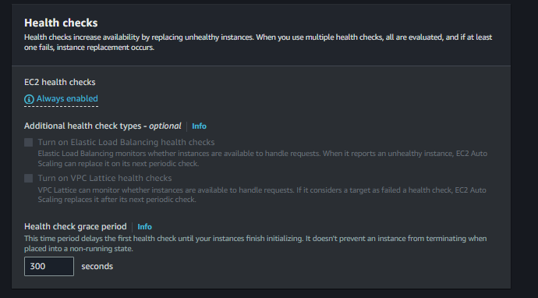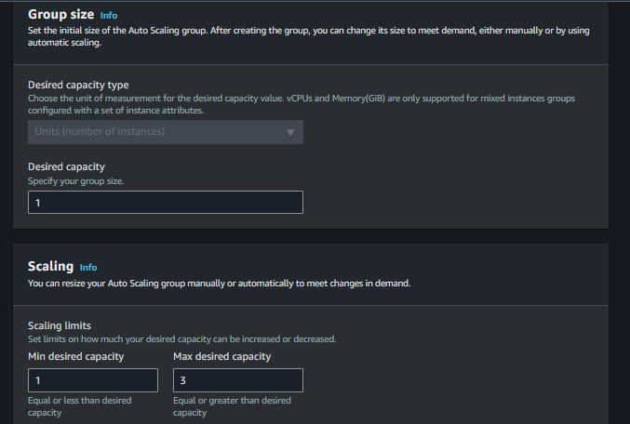

1. **Configure Scaling Policies:**
   * Set desired, minimum, and maximum instance counts.
   * Define scaling policies based on metrics like CPU utilization.

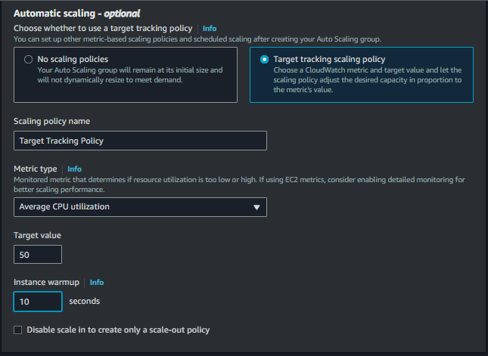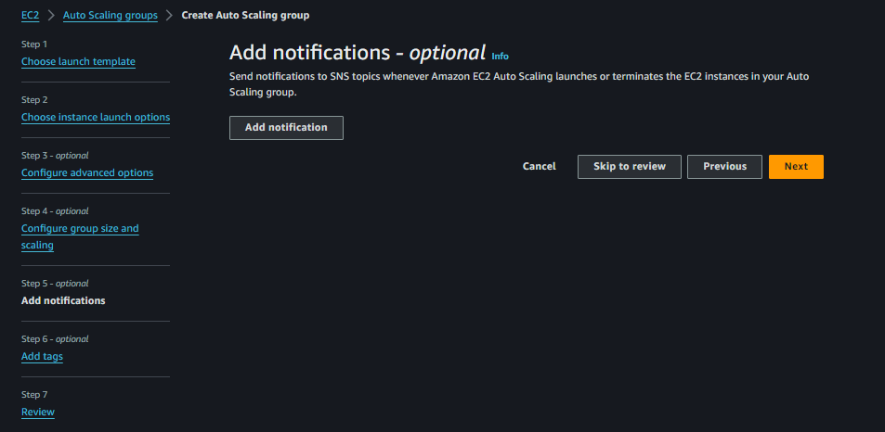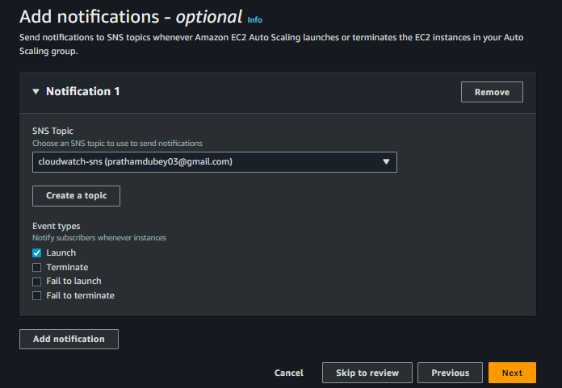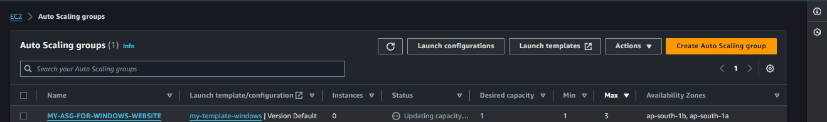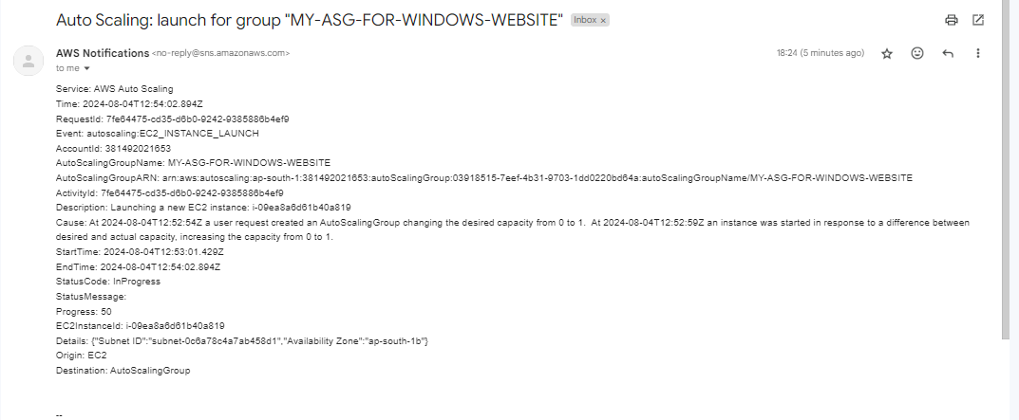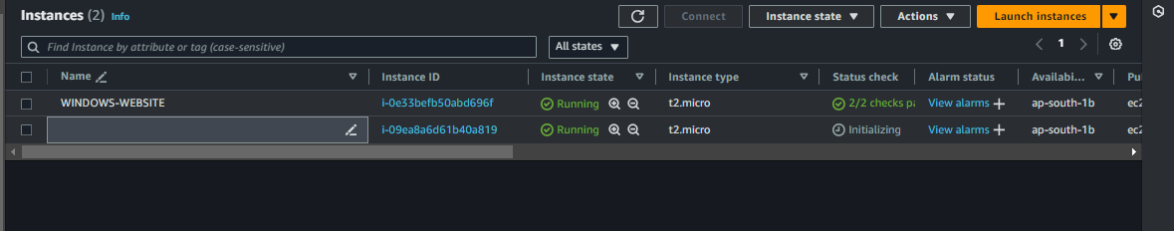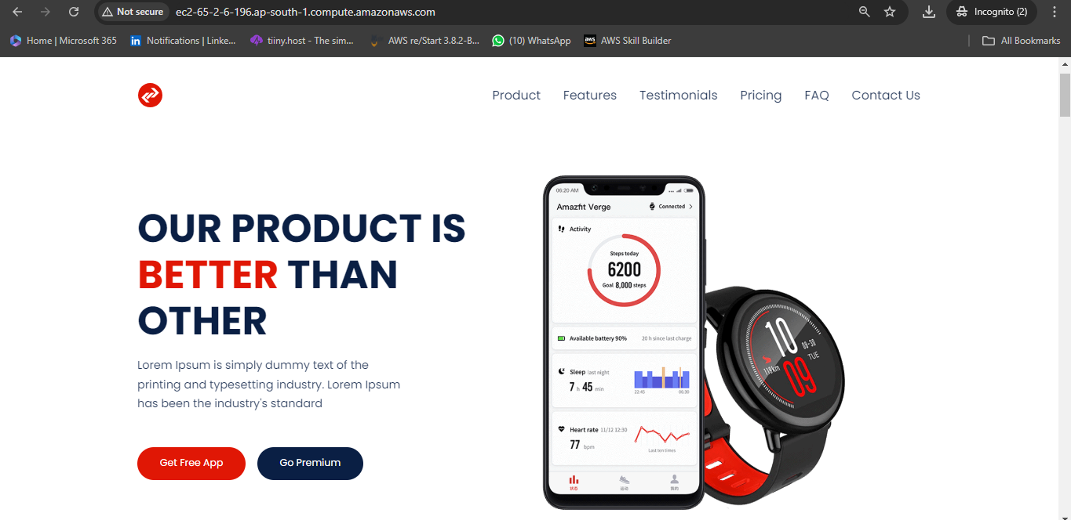

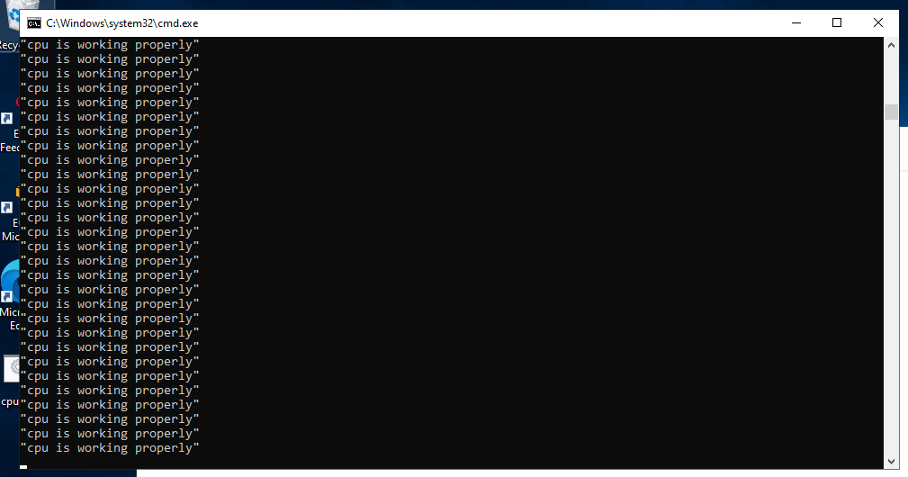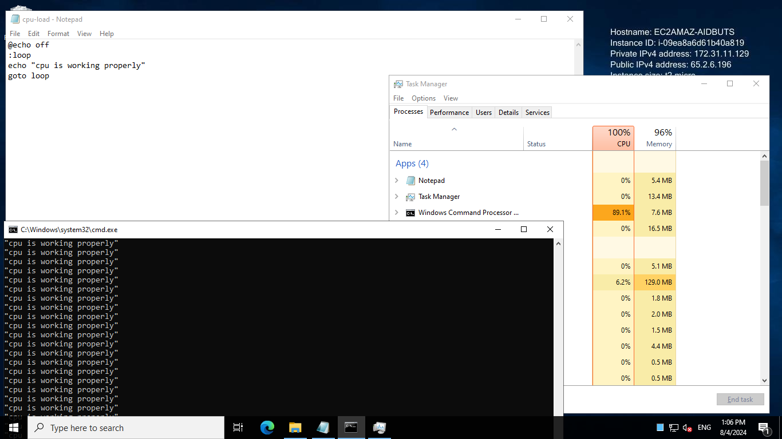

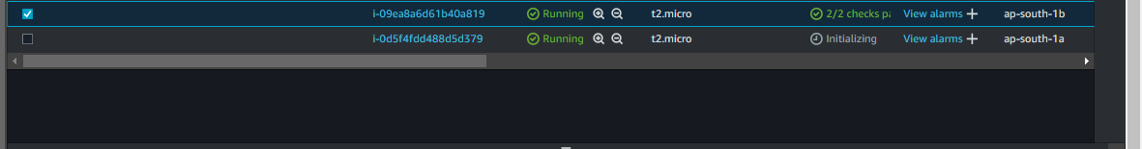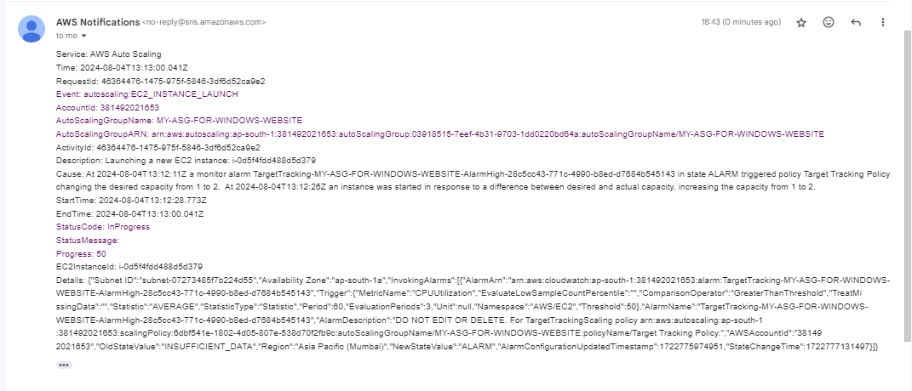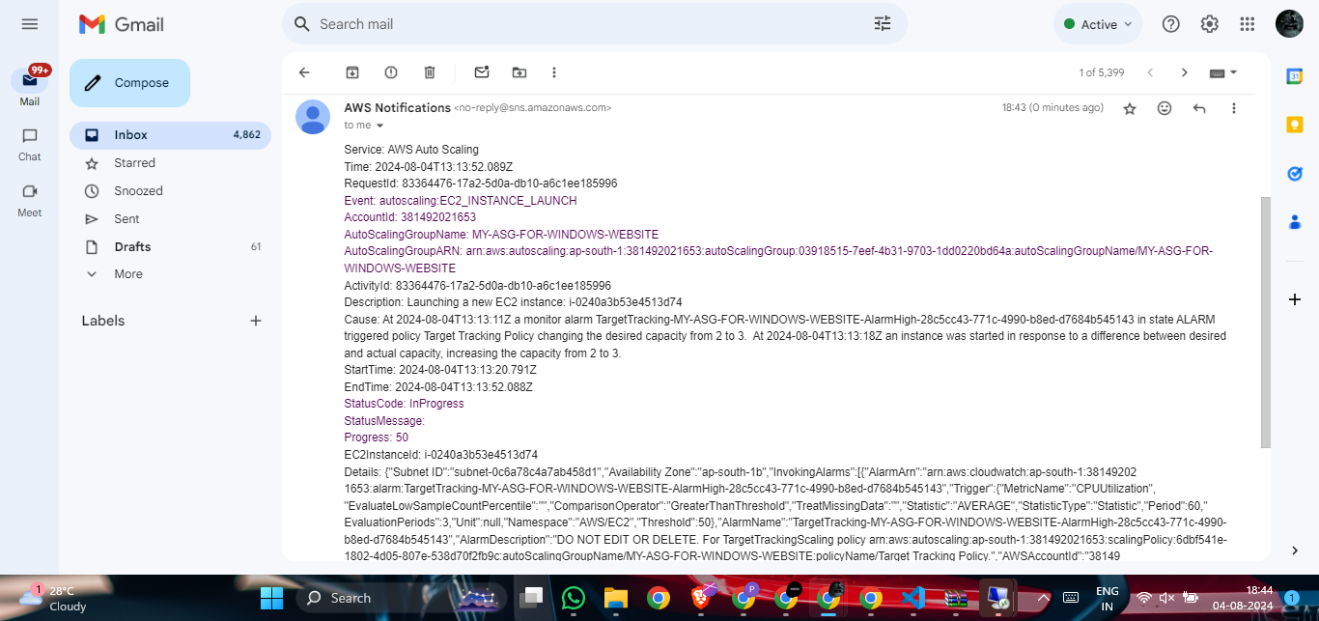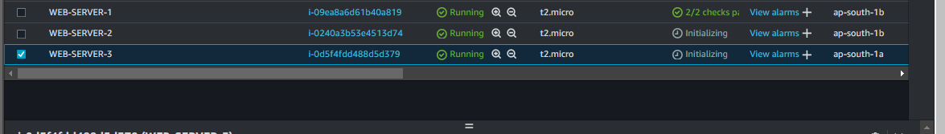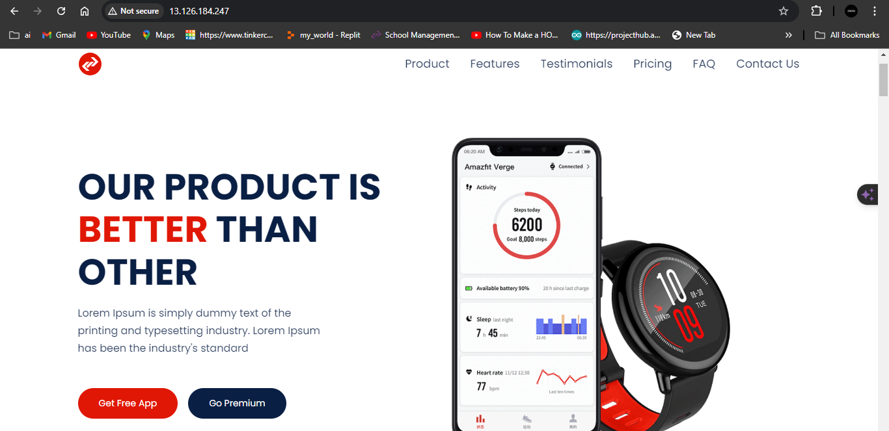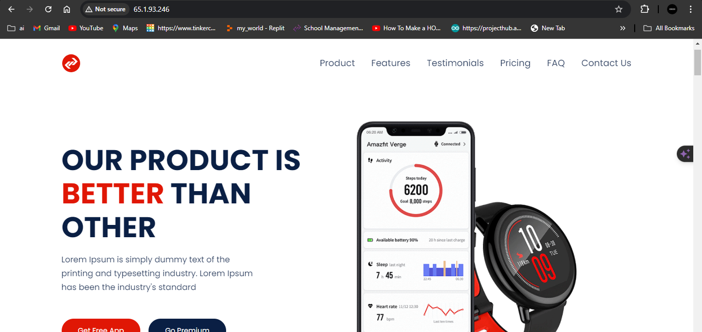

### **Step 6: Attach a Load Balancer**

**Objective:** Distribute incoming internet traffic across healthy instances.

1. **Create an Application Load Balancer:**
   * Navigate to "Load Balancers" in the EC2 dashboard.
   * Click "Create Load Balancer" and select "Application Load Balancer."
   * Configure basic settings such as name, scheme, and IP address type.
   * Set up listeners (HTTP) and configure security settings.

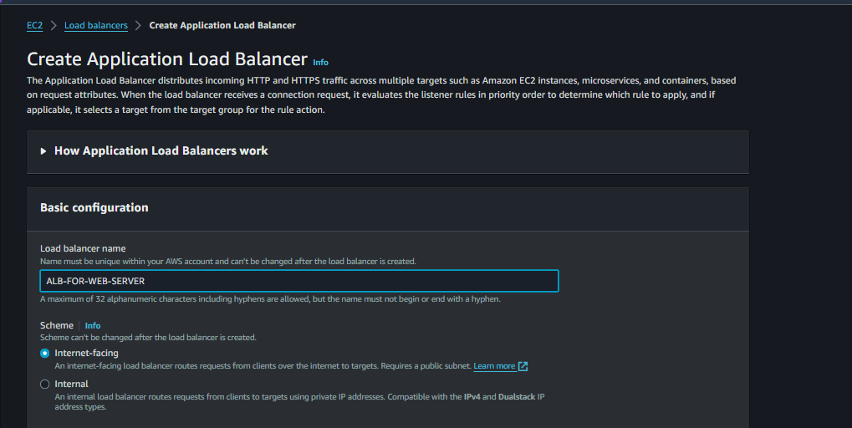

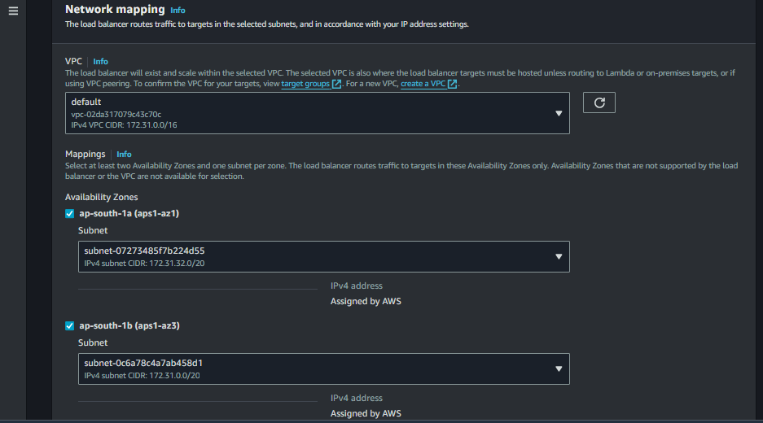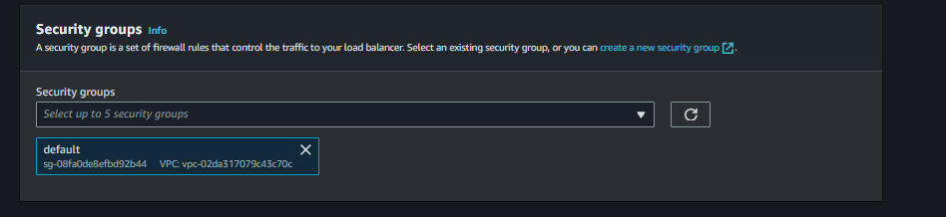

1. **Create a Target Group:**
   * Define a target group for the instances managed by the Auto Scaling group.

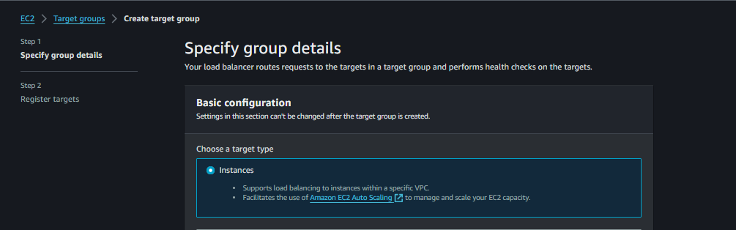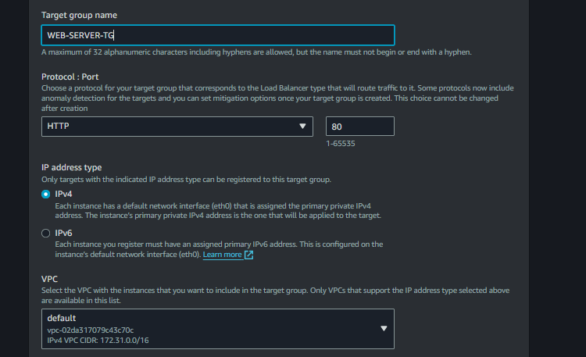

* + Register your instances to the target group.

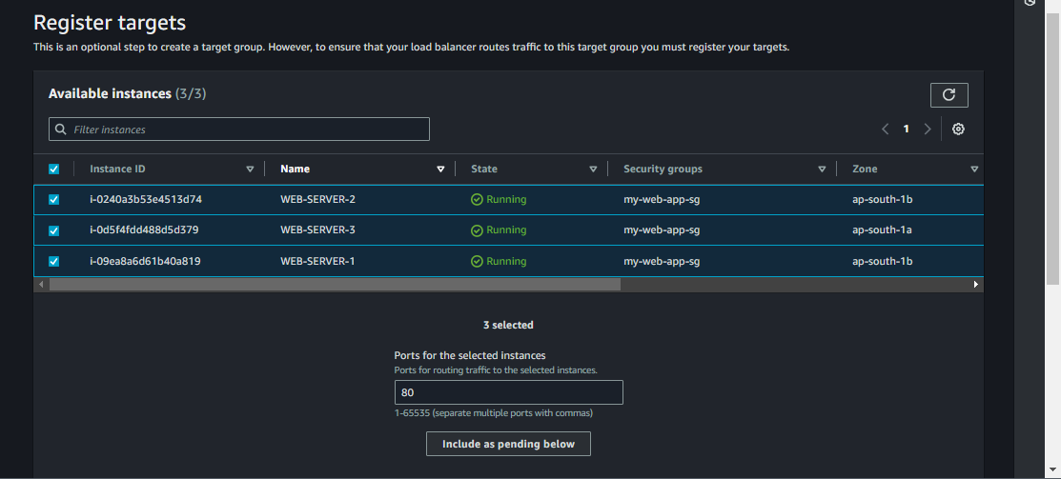

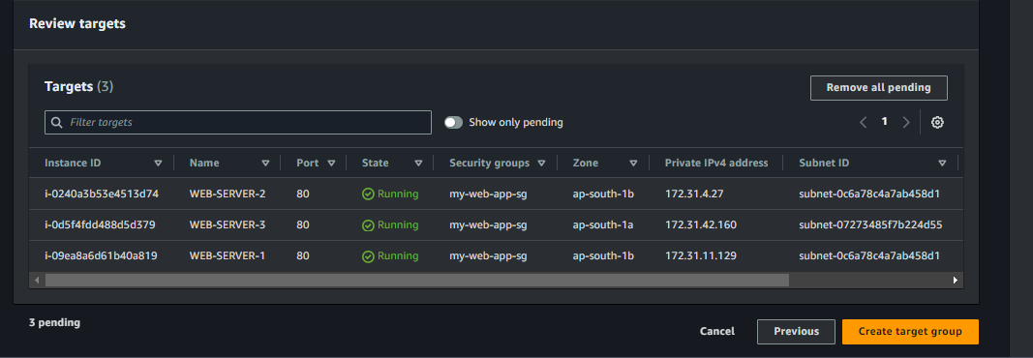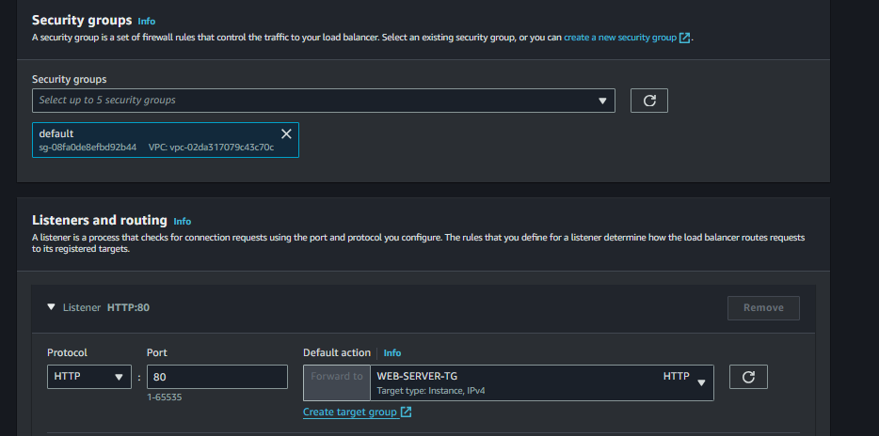

1. **Attach Load Balancer:**
   * Go to the Auto Scaling group configuration.
   * Attach the load balancer and target group.

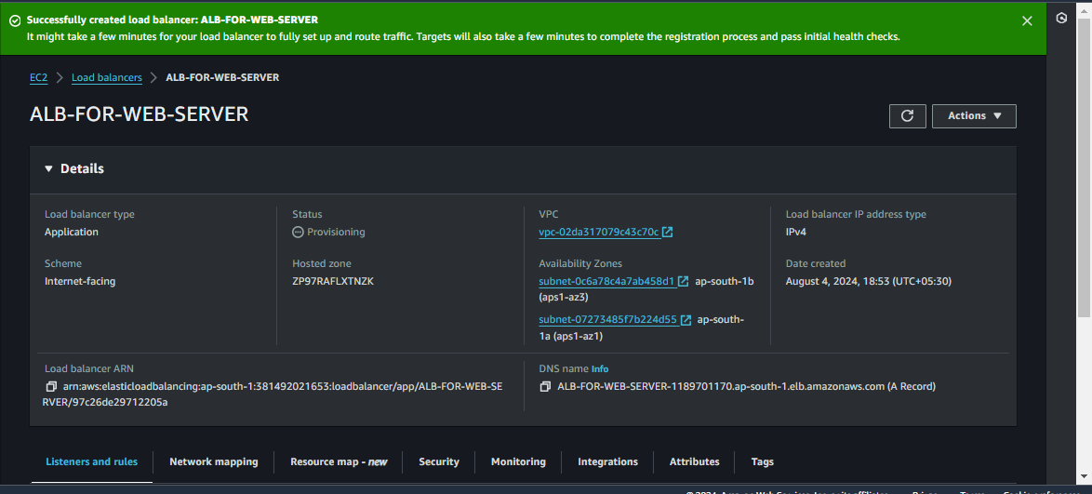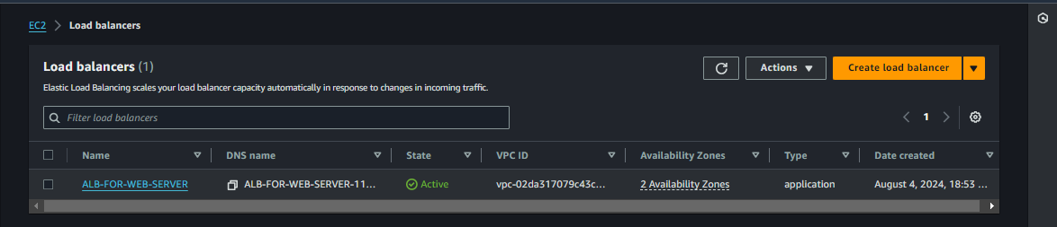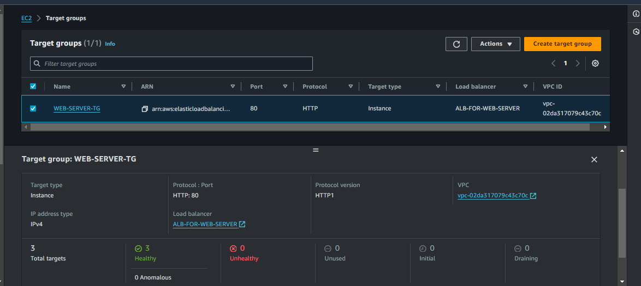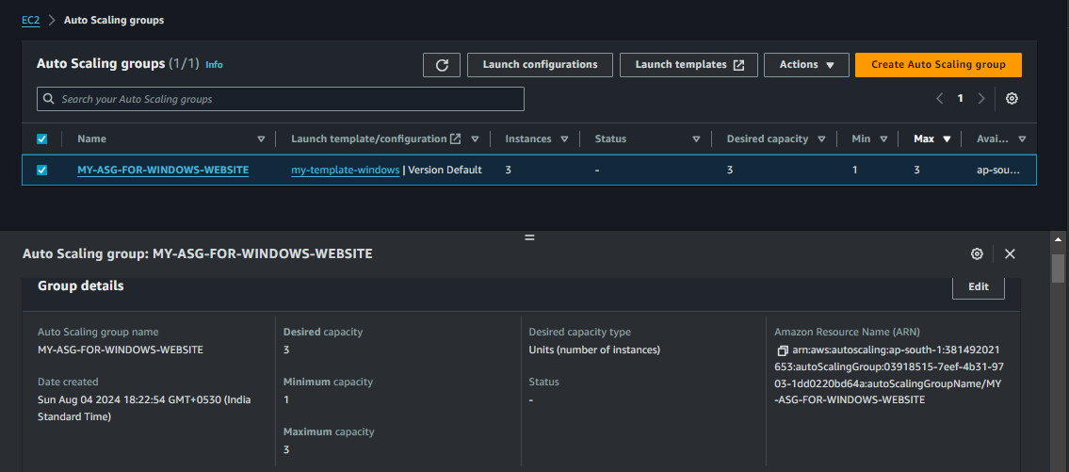

**SCAL IN**

1)CLOSE THE RUNNING PROCESS (CPU-LOAD.BAT)

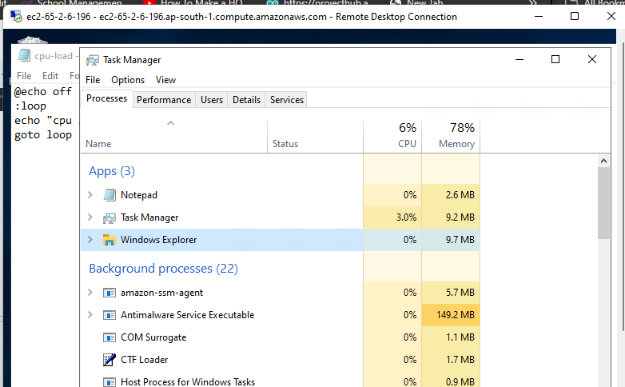

**Wait for 5 minutes for the CPU to return to normal levels, and any instances that were created due to the load will be terminated automatically**

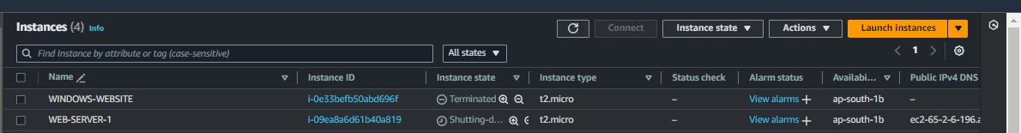

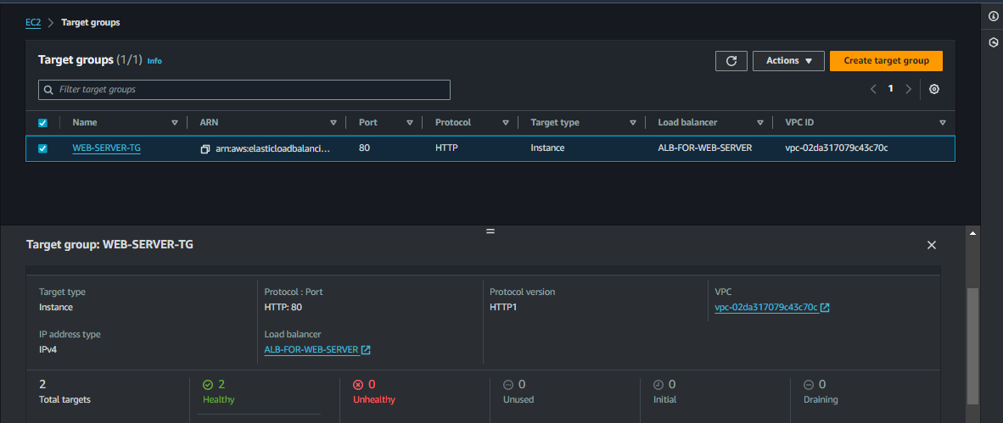

NOTE

I**dentify the Load Balancer's Security Group**: Find the security group associated with your load balancer. This is necessary to configure rules that allow traffic only from this source.

1. **Modify the Instance's Security Group**:
   * **Access the AWS Management Console**: Go to the EC2 Dashboard.
   * **Select the Instance**: Find and select the instance you want to modify.
   * **View Security Groups**: In the instance details, locate the security groups section and select the one associated with your instance.
   * **Edit Inbound Rules**: Modify the inbound rules of the instance's security group:
     1. Remove any existing inbound rules that allow direct access from the public.
     2. Add a new inbound rule to allow all traffic (or specific ports as needed) from the load balancer's security group. Select "All traffic" or specific protocols as needed, and in the source field, choose the load balancer's security group ID.

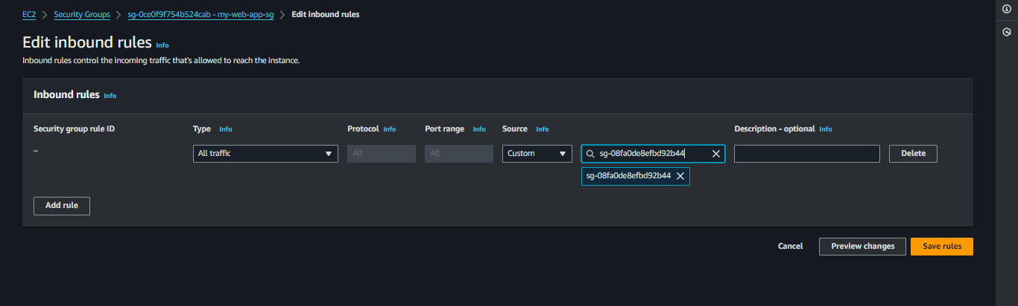

1. **Save Changes**: Ensure that the changes are saved to apply the new security configuration.

By doing this, you ensure that traffic can reach the EC2 instance only through the load balancer, preventing direct access via the instance's public IP address. This helps improve security by controlling the flow of traffic into your application.

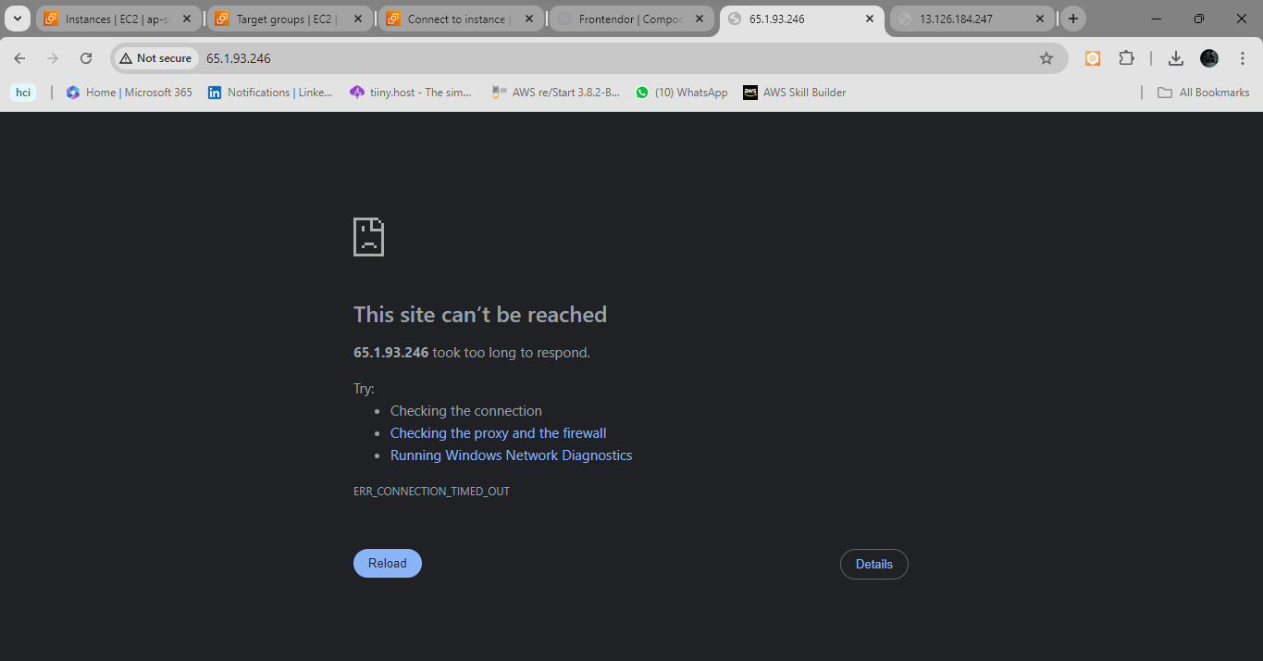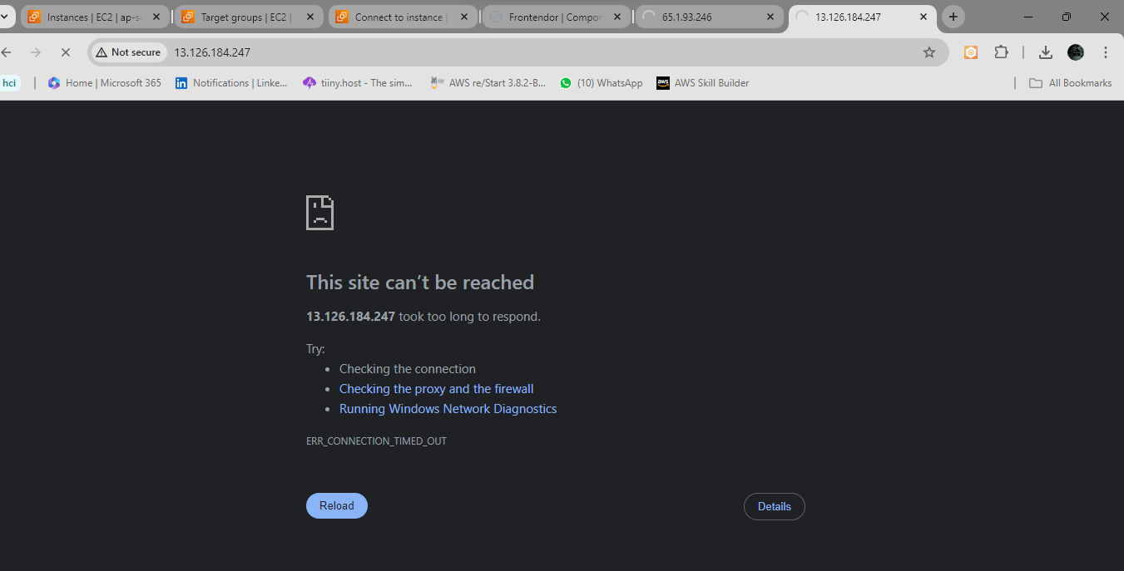

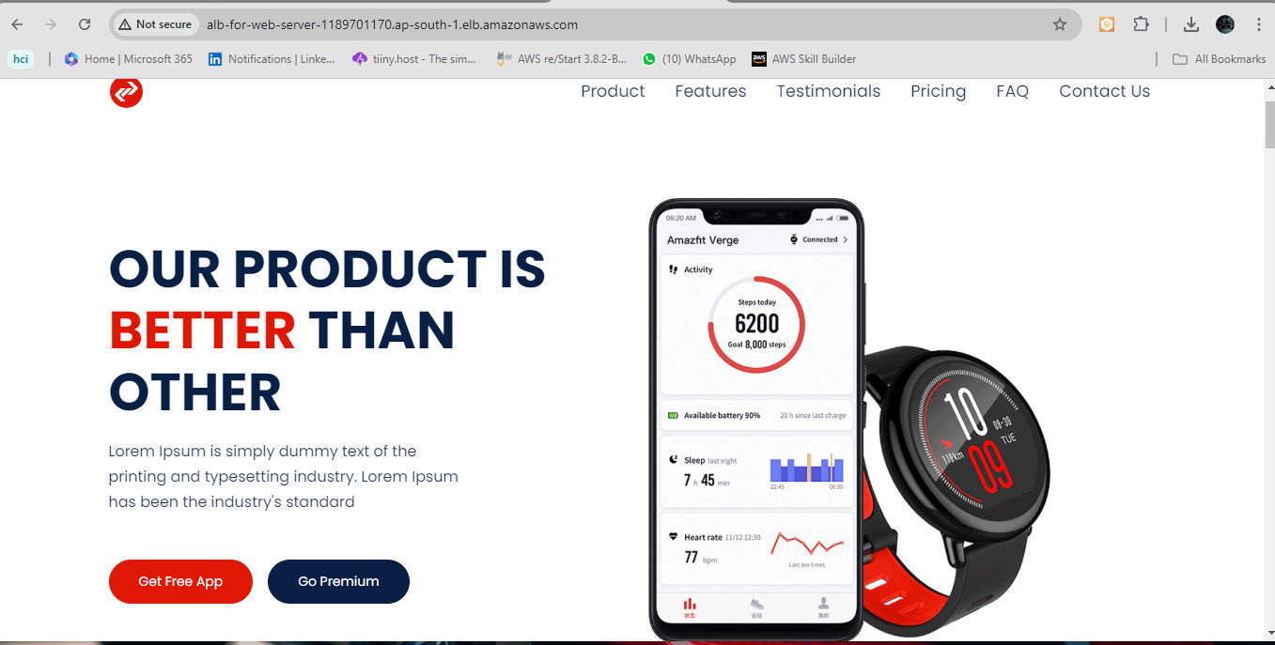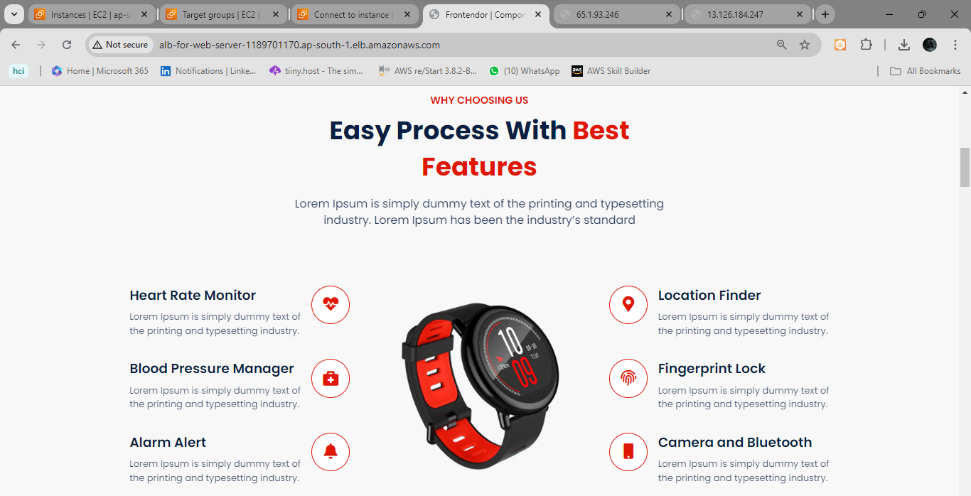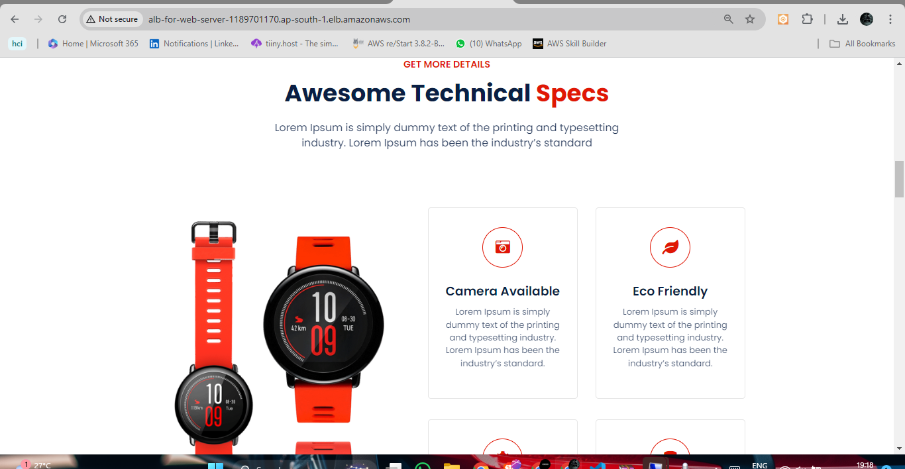

S3-bucket versioning

